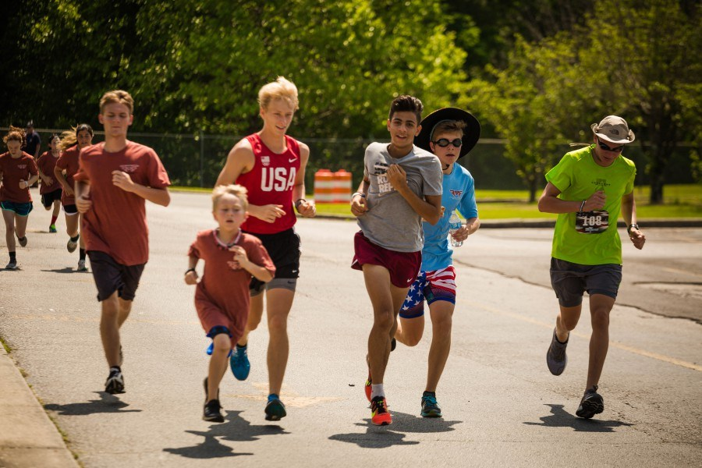

Calling all HCS Employees!

We, The Mark Forester Foundation, would like to thank Haleyville City Schools for the support you’ve generously given over the last THIRTEEN years. Because of your support, we have been able to give numerous scholarships to Haleyville High School graduates. We have also been able to make monetary contributions to the Haleyville City Schools to be used where needed, such as helping the middle school band and for repairs at the high school. Once again, this year we thought it would be fun to donate $1000 to the school who has the most faculty and staff participating in the walk or race (must be at least 10 faculty/staff members from school to receive $1000 donation). To show our appreciation, we will also be giving away a $100 gift card and other door prizes the day of the race to HCS Employees that show up and sign up. We are also offering a SPECIAL – HCS employees will only pay a $20 race/walk entry fee for any event they wish to participate in. That’s $20 to participate in the walk or race (1 mile FUN RUN is FREE for HCS employees).

There will be a table set up under the merchandise tent at the race labeled HCS Faculty and Staff. Sign in at this table to be entered for any and all prizes and to support your school.

We hope to have a HUGE turnout of HCS employees. Please mark your calendars for the weekend of May 20, 2023 and come join us as we celebrate the life of our hometown hero.

“Greater love hath no man than this, that a man lay down his life for his friends”
John 15:13

