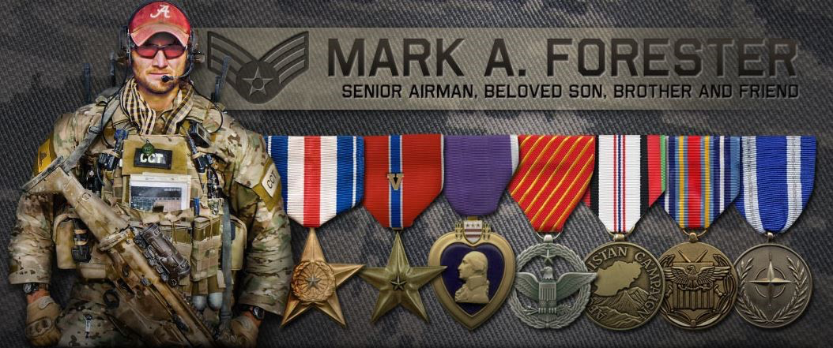
The Thirteenth Annual
Mark Forester Price of Freedom Race
Half Marathon 5k 1 mile
First Race starts at Haleyville High School Football Field/Track at 9:00am
May 20, 2023 Rain or Shine
Pre-registration form at www.markaforester.com
Registration 7:00 am on race day
Award Presentation will be at 11:00 am

REGISTRATION before May 10, 2023 FOR MORE INFORMATION:
$50.00 – Half Marathon visit www.markaforester.com
$20.00 – 5K online registration ends May 10 @ noon
$10.00 – 1 mile

Registration after May 10, 2023 AWARDS
$75.00 – Half Marathon 1st place in each age division
$30.00 – 5k
$15.00 – 1 mile

Military Pricing (Active Duty): $20 (can run any & all races)

Please mail registration to:
The Mark Forester Foundation
c/o Lauren Tinker
171 Briscoe Road
Haleyville, Alabama 35565

Make checks payable to: The Mark Forester Foundation - www.markaforester.com

Join us as we celebrate the life and birthday of a hero,
Mark A. Forester.

“Greater love hath no man than this, that a man lay down his life for his friends”
John 15:13

The Mark Forester Price of Freedom Race
Half Marathon/5k/1mile Fun Run

May 20, 2023
Please mail registration to:
The Mark Forester Foundation
c/o Lauren Tinker
171 Briscoe Road
Haleyville, Alabama 35565
Make checks payable to: The Mark Forester Foundation
www.markaforester.com

Name: ____________________________________________________________________
Age: (on race day) _______ Birth Date: __________________ Male: ____ Female: ____
Address: __________________________________________________________________
State: __________ Zip: _________________________
Phone: ____________________________________________________________________
Email: ____________________________________________________________________

Shirt Size:

Youth Small Youth Medium Youth Large

Small Medium Large X-Large XX-Large

* The race shirts are only being offered in tri-blend material this year.

Race: Half 5k 1mile (circle all races you will participate in)

I, individually (or as a parent or guardian of a minor child under the age of 18 participating) state that I (or my minor child) is in proper physical condition to run/walk in a half marathon/10k/5k/1 mile race and request to participate in The Mark Forester Price of Freedom half marathon/10k/5k/1 mile race, May 20, 2023; and, In consideration of The Mark Forester Foundation permitting the undersigned or his/her minor child to engage in the aforesaid activity, the undersigned does, for himself/herself, his/her heirs, assigns, executors and administrators, remise, release and forever discharge The Mark Forester Foundation, its officers, agents, and/or employees, event sponsors , its officers, agents and/or employees and event volunteers from all manner of action and actions, suits, and sums of money, dues, claims, or demands, whatsoever, which arise out of or in any manner grow out of, property damage sustained by the undersigned or his/her minor child or injuries or death sustained by the undersigned or his /her minor child, including injuries known or unknown, by reason of being permitted to participate in the aforesaid activity in the City of Haleyville, Alabama. THE UNDERSIGNED has read this Release and fully understands the same.

____________________________________________________________________________________________
Signature Participant or Parent/Legal Guardian Date

